Long Answer Questions:

Choose two questions from the following and answer them.

1. Reflect on the causes and consequences of the Winnipeg General Strike. How did this pivotal event reshape the perception of labour among Canadians?

2. Using two examples, explain the Historical Significance of the involvement of Canadians in Aircraft during the First World War:

3. Describe how the First World War started with reference to at least two major political and ideological currents or events that led to the conflict. Moreover, how did these mix to create tension amongst various nations?

For the primary source analysis questions from pages two to five, select three questions and provide comprehensive answers to each one below the image.

Source 1:

1. a) What do you see here? list a few (2-3) observations of what is occurring in this primary source

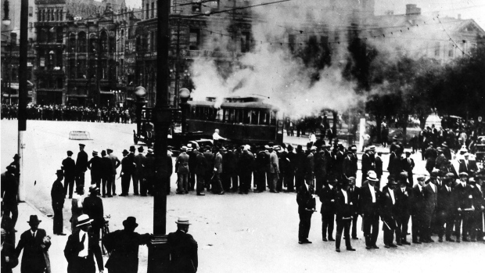
B) How do these observations reflect the state of Canadian unrest with labour conditions and wages after the First World War?

Source 2 and 3:

The only answer for either poster A or B not both!

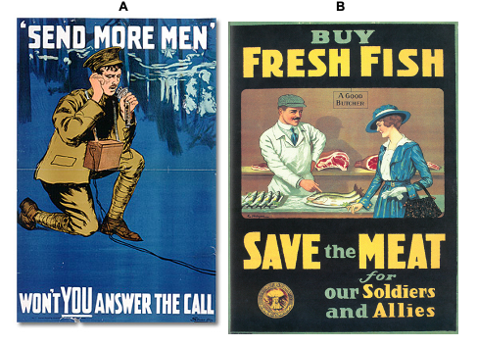
2. a) Identify the target audience (who it is created for) of the poster and identify one piece of evidence (details from the poster) that backs up your answer.

b) Is this poster effective (does the message get across clearly, and is it appealing)? Use specific examples to support your answer.

c) Why is this primary source significant to Canadian History?

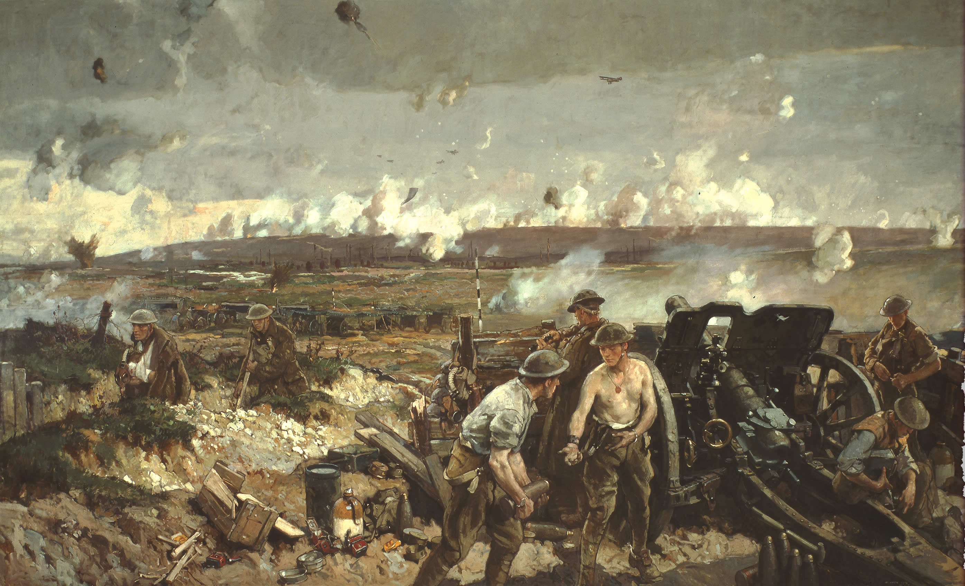

Source 4

- How does this painting use imagery to reflect the spirit of the battle at Vimy Ridge? Your answer should comment on at least two observations of the scene depicted in the painting.
- Does this painting reflect Canadian historical narratives of the battle at Vimy or challenge them? Answer in 100-150 words.

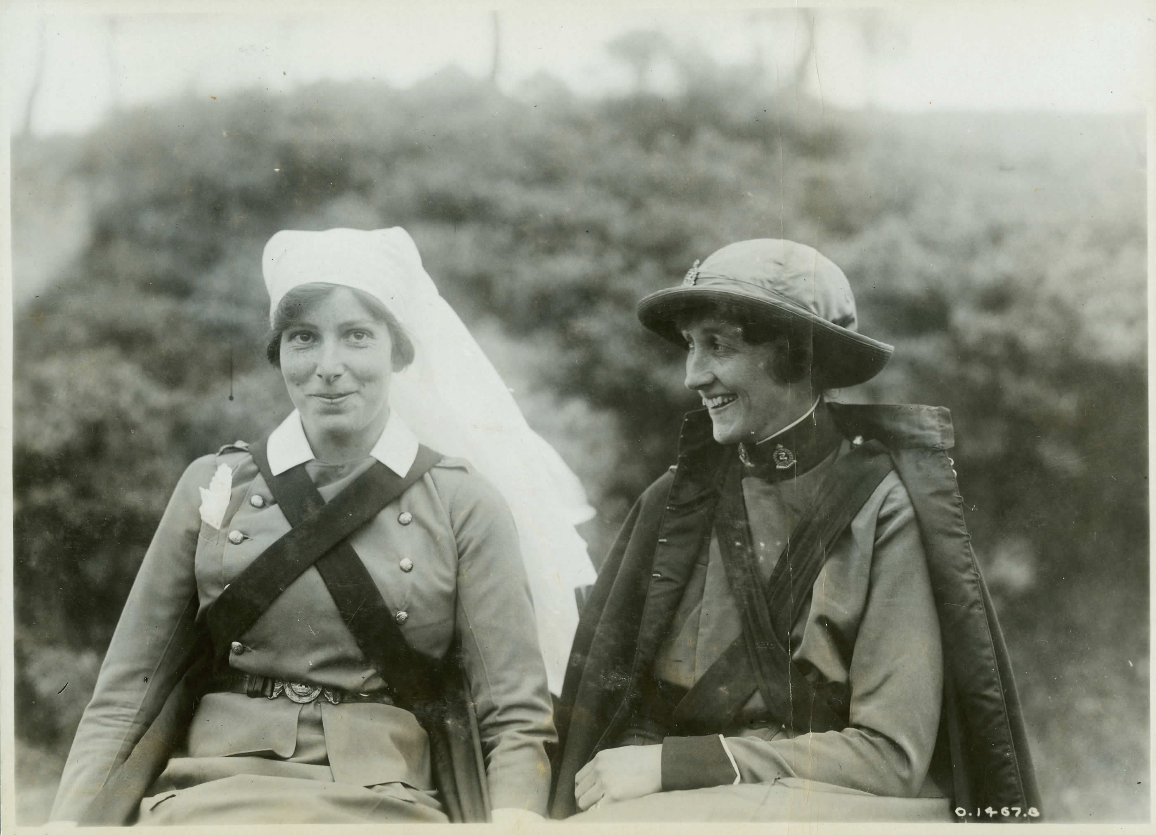

Source 5:

- How do these women reflect or reject gender norms surrounding women at the time? Regarding a few observations you make, state your opinion on the photographic evidence.
- How does the image here display women's key impacts regarding their rights and increased respect by their male counterparts during and after the war effort?

